Wordament Solver CV

Requirements

1. Windows 8 pc with wordament installed
2. Install tesseract-ocr-setup-3.02.02.exe ( <https://code.google.com/p/tesseract-ocr/downloads/detail?name=tesseract-ocr-setup-3.02.02.exe&>)
3. Internet Access.

Instruction

Keep wordament app in view, so that solver could read letters.

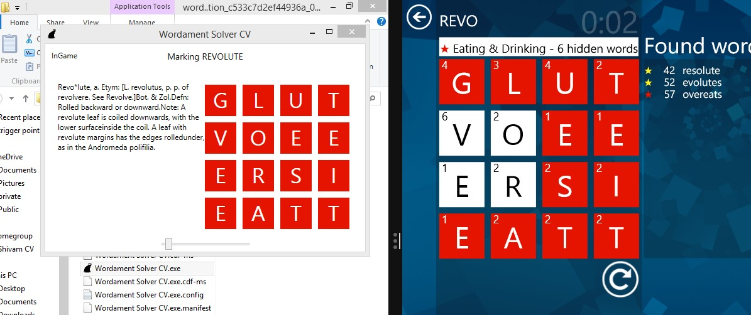

Disclamer :

This App developer is in no way responsible for any misuse of this app. Thank you